The Port Project is a collaborative project between the Center for Forensic Sciences, Research and Education, US Customs and Border Protection (CBP), and the US Department of Justice (DOJ). Our organization identifies the drugs that cross our borders, especially at airport entries.

The following are some graphs that I created for the Port Project.

1 square = 11.13 cases
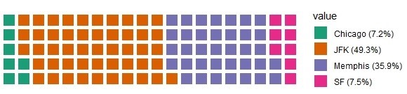
Figure 1. Proportion of Drug Cases Coming from Each Port for the Entire Year of 2019 (N =1113 cases).
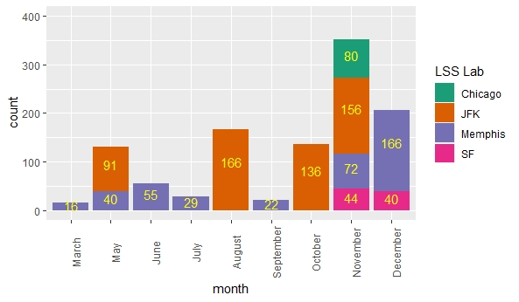
Figure 2. Number of Drug Cases Received Monthly from Each Port

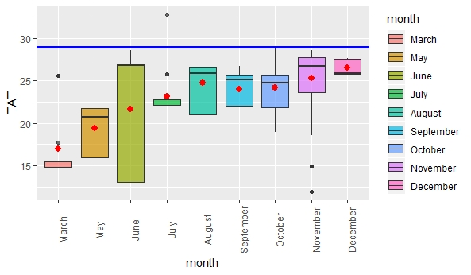
Figure 3. Boxplot for Turnaround Time (TAT), From Time of Receipt of Samples to Time Reported.

The red dots represent the average of turnaround time (TAT) for every month, which is the amount of time needed to identify a drug case. From the graph, the turnaround time increases over the months as the number of cases increase. The blue line denotes the maximum number of days for a case identification. There was only one case in July that exceeded 29 days.
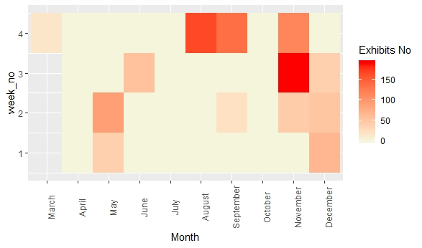
Figure 4. Heatmap for Exhibits (number of drug cases) Received per Week.
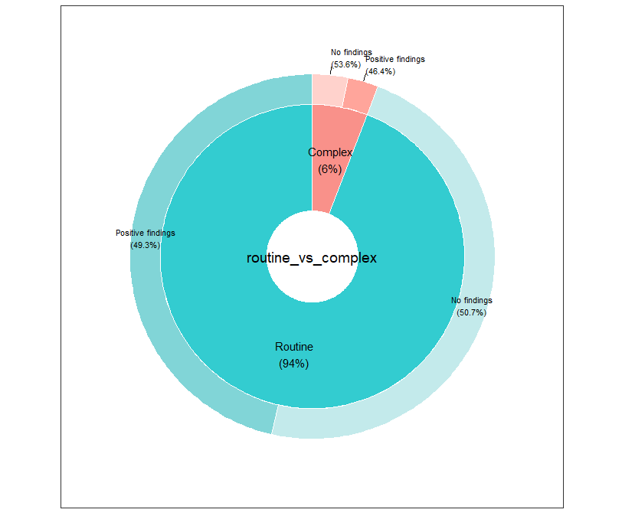
Figure 5: Sunburst Plot of Exhibit Characterization
This sunburst plot explains the distribution of case type. Most drug cases are routine cases, meaning that they are easy to identify. Complex cases consist of difficult to pinpoint substances that are trying to cross our border.

The following 2 graphs are Sankey graphs that shows the distribution of drugs entering our borders through the different ports.
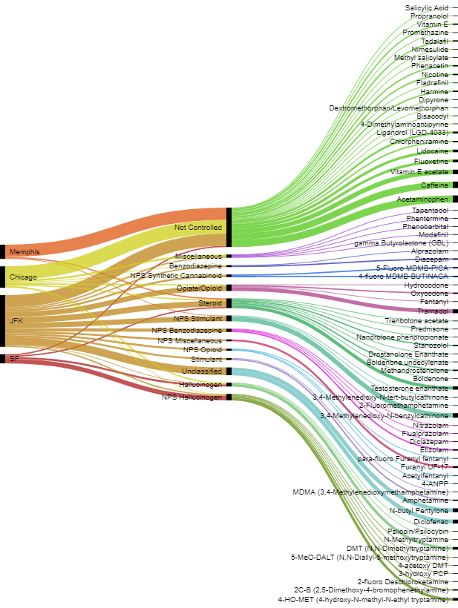
Figure 6. Sankey Diagram of Routine Cases Received from Each Port in November and December of 2019 Identified into Compound and Classification.
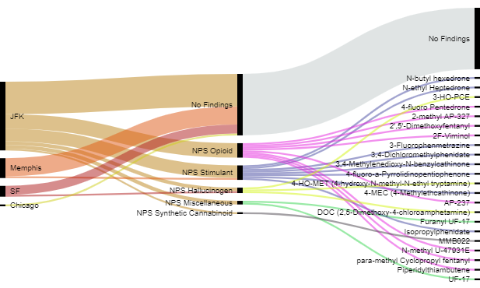
Figure 7. Sankey Diagram of Complex Cases Received from Each Port since March 2019 Identified into Compound and Classification.
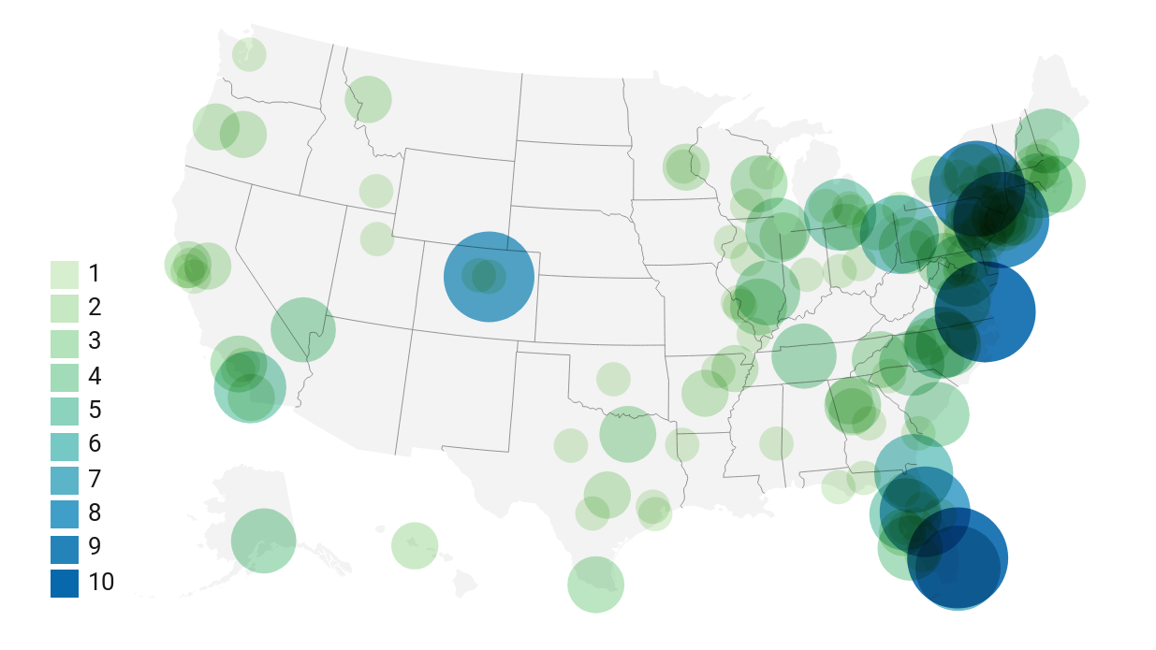
Figure 8. Symbol Map for Number of Packaged Substances Per Destination (3 Digit Zip Code) in the United States.
This is a symbol map that shows the number of packaged substances addressed to each location. The east coast is the primary targets of the drugs.

